Annotated clicks of Pantropical spotted dolphins from the Northern Mariana Islands

These annotated files of clicks are *Stenella attenuata* recorded during the Marine Mammal and Sea Turtle Survey and Density Estimates for Guam and the Commonwealth of the Northern Mariana Islands (MISTCS). Sound files were provided by Dr. Tom Norris at Biowaves, Inc. Click annotations were entered into logs based on gross characteristics to define a ‘category’. There are separate logs for each category.

Click categories (examples provided for all but “Other” types) were determined to be:

* “good”: good signal to noise ratio, a bandwidth averaging 3kHz to 43kHz and an average length of 0.0061s .
* “maybe ”: mediocre signal to noise ratio and a bandwidth averaging 5kHz to 42kHz and an average length of 0.0082s.
* “15-50kHz”: clicks that may be *S.attenuata*, with good or adequate signal to noise ratio and a bandwidth averaging16kHz to 45kHz and an average length of 0.0056s.
* “2-32kHz”: clicks that may be *S.attenuata*, with good or adequate signal to noise ration and a bandwidth averaging 2-32kHz and an average length of 0.0062s.
* “Clicktrain”: high frequency clicks with an average frequency range of 21-47kHz, exhibiting inter-click intervals too short to measure with any accuracy.
* “Other1”: clicks that may not be *S.attenuata* with variable SNRs, a bandwidth averaging 2kHz to 28kHz and an average length of 0.0066s.
* “Other2”: clicks that may not be *S.attenuata* with variable SNRs, a bandwidth averaging 6kHz to 23kHz and an average length of 0.0062s.
* “Other3”: clicks that may not be *S.attenuata* with variable SNRs, a bandwidth averaging 9kHz to 33kHz and an average length of 0.0069s.
* “Other4”: that may not be *S.attenuata* clicks with variable SNRs, a bandwidth averaging 15kHz to 35kHz and an average length of 0.0044s.
* “Other5”: that may not be *S.attenuata* clicks with variable SNRs, a bandwidth averaging 4kHz to 46kHz and an average length of 0.0113s.

Metadata:

* MISTCS Final Report 8.10.07.pdf
* MISTCS Final Report Appendix A-2 8.10.07.pdf

The final report and Appendix A (Table 3.2 Marine Mammal and Sea Turtle Sighting Record) specifies species sightings per day (with sighting times) , and not for each sound file recorded on that day. Annotated sound files had time stamps (indicated in file name) that corresponded to sighting times, and files just before, just after, or at least during the same day.

|  |  |  |  |  |
| --- | --- | --- | --- | --- |
| **File Name** | **Visual ID Status** | **time of sighting** | **Length (s)** | **N annotated clicks** |
| MISTCS070123-072333.wav | S.attenuata, T.truncatus | 7:23:33 | 386 | 104 |
| MISTCS070123-074000.wav | no confirmed visual ID | na | 600 | 169 |
| MISTCS070123-082000.wav | no confirmed visual ID | na | 600 | 20 |
| MISTCS070123-153000.wav | S. attenuata | 15:37 | 600 | 35 |
| MISTCS070124-113000.wav | Stenella, Pepenocephala | 11:36 | 600 | 308 |
| MISTCS070124-113934.wav | no confirmed visual ID | na | 120 | 30 |
| MISTCS070127-072932.wav | no confirmed visual ID | na | 60 | 4 |
| MISTCS070127-073000.wav | no confirmed visual ID | na | 600 | 15 |
| MISTCS070127-074000.wav | no confirmed visual ID | na | 600 | 32 |
| MISTCS070127-174000.wav | S. attenuata | 17:45 | 600 | 330 |
| MISTCS070127-175000.wav | no confirmed visual ID | na | 300 | 27 |
| MISTCS070314-093000.wav | S. attenuata, Unid. Rorqual | 9:35 | 599 | 46 |
| MISTCS070314-094000.wav | no confirmed visual ID | na | 600 | 11 |
| MISTCS070316-073000.wav | no confirmed visual ID | na | 599 | 205 |
| MISTCS070316-075000.wav | S. attenuata | 07:54 | 600 | 40 |
| MISTCS070316-080000.wav | no confirmed visual ID | na | 600 | 246 |
| MISTCS070316-081000.wav | no confirmed visual ID | na | 44 | 6 |
| MISTCS070318-090000.wav | S. attenuata | 9:05 | 600 | 3451 |

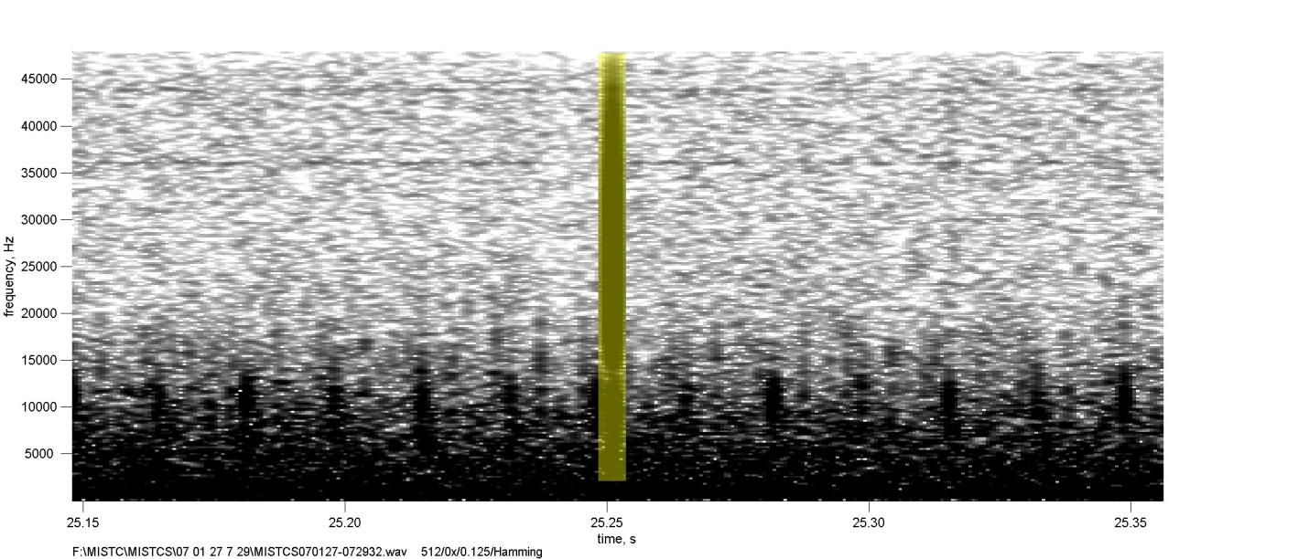 “ “Good”

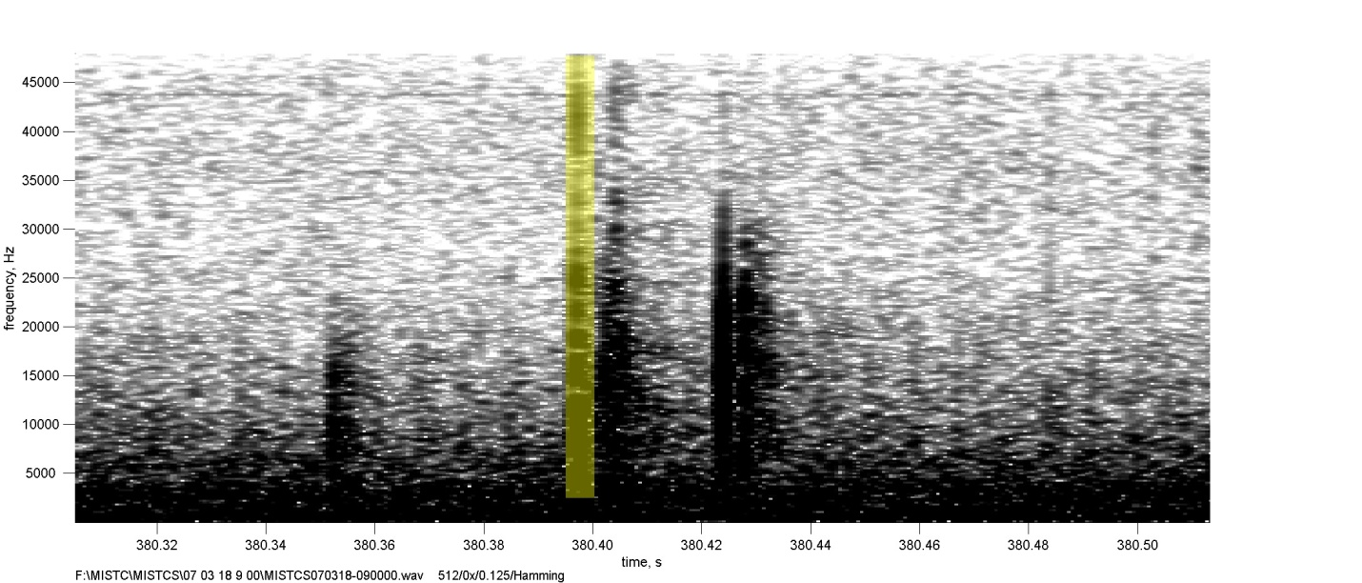

“Maybe”

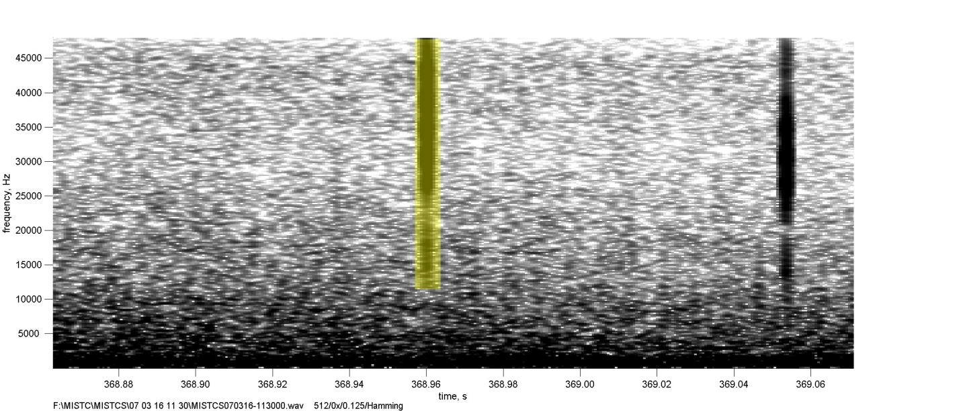

“15-50kHz”

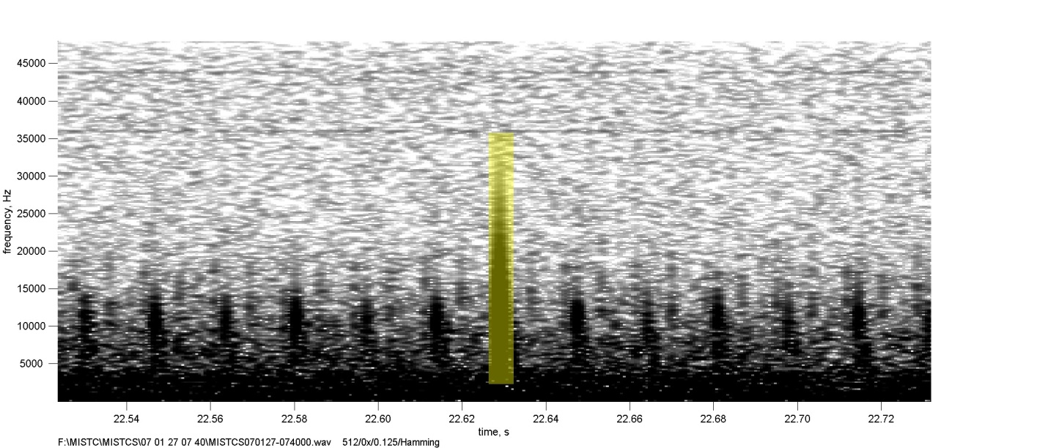

“2-32kHz”

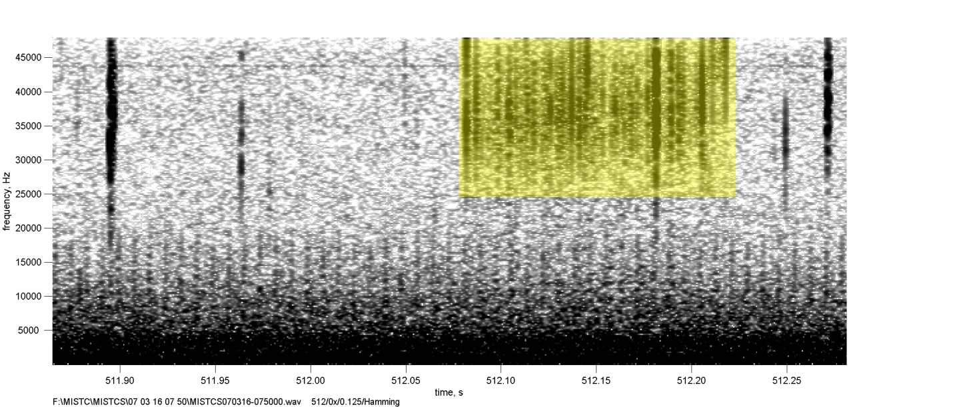

“Clicktrain”