Annotated clicks of Pantropical spotted dolphins from the Bahamas

These annotations of clicks are from Stenella attenuata recorded on the AUTEC range in the Bahamas Sound files were provided by WHOI. Annotations are only for good quality clicks up to 583.782s in the sound file, which is 1800s long. There are no annotations of clicks not meeting this criteria.

“good” clicks were defined as having excellent to good signal to noise ratio, a bandwidth averaging 5kHz to 46kHz and an average length of 0.005s . (see example, below).

Metadata:
- Stenella-WHOI-MetaData.xls

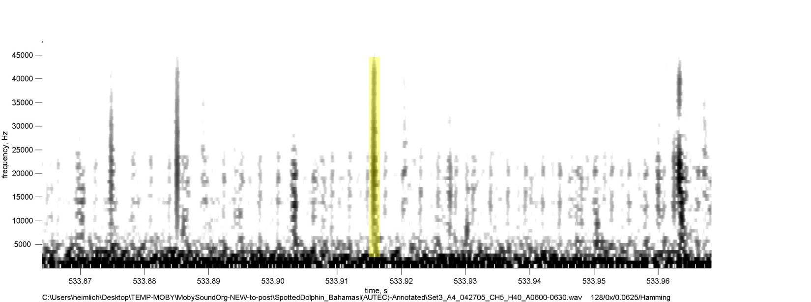
“ “Good”

